You are given the head of a linked list and two integers m and n.

Traverse the linked list and remove some nodes in the following way:

* Start with the head as the current node.
* Keep the first m nodes starting with the current node.
* Remove the next n nodes
* Keep repeating steps 2 and 3 until you reach the end of the list.

Return *the head of the modified list after removing the mentioned nodes*.

**Example 1:**

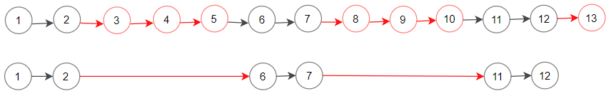

**Input:** head = [1,2,3,4,5,6,7,8,9,10,11,12,13], m = 2, n = 3

**Output:** [1,2,6,7,11,12]

**Explanation:** Keep the first (m = 2) nodes starting from the head of the linked List (1 ->2) show in black nodes.

Delete the next (n = 3) nodes (3 -> 4 -> 5) show in read nodes.

Continue with the same procedure until reaching the tail of the Linked List.

Head of the linked list after removing nodes is returned.

**Example 2:**

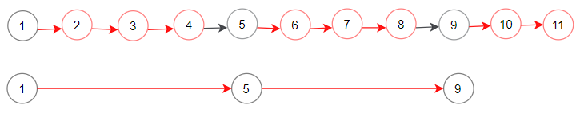

**Input:** head = [1,2,3,4,5,6,7,8,9,10,11], m = 1, n = 3

**Output:** [1,5,9]

**Explanation:** Head of linked list after removing nodes is returned.

**Constraints:**

* The number of nodes in the list is in the range [1, 104].
* 1 <= Node.val <= 106
* 1 <= m, n <= 1000

**Follow up:** Could you solve this problem by modifying the list in-place?